Chapter 18, Problem 60.

A bandlimited signal has the following Fourier series representation:

i_{s}(t) = 10 + 8 cos(2π t + 30°) + 5 cos(4π t - 150°) mA

If the signal is applied to the circuit in Fig. 18.55, find v(t).

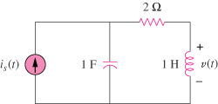

Figure 18.55
For Prob. 18.60.

